PROLONGED PRESERVATION OF HUMAN LIVER USING NORMOTHERMIC MACHINE PERFUSION PROCESS

ABSTRACT

Prolonged normothermic machine perfusion (PNMP) has emerged as a promising technique for the preservation and assessment of discarded human organs intended for transplantation. Traditional cold storage methods have limitations in maintaining organ viability, particularly for extended periods, resulting in a significant number of viable organs being discarded. PNMP offers a potential solution to this critical issue by providing a continuous oxygenated perfusion of discarded organs at normal body temperature, thereby replicating physiological conditions and supporting cellular function. There are so many advantages of PNMP over conventional cold storage techniques. By maintaining organs at normothermic conditions, PNMP provides continuous organ assessment, which allows for real-time monitoring of organ function and viability. Furthermore, PNMP extends the preservation time, offering more flexibility in organ allocation and transportation, and potentially increasing the pool of available organs for transplantation.

INTRODUCTION

- Background of organ transplantation:
Organ transplantation stands as one of the most remarkable achievements in modern medicine, offering life-saving treatment for patients suffering from end-stage organ failure. The history of organ transplantation dates back to the early 20th century, with initial attempts primarily focused on skin and corneal grafts. However, it wasn't until the mid-20th century that the field witnessed significant advancements with the successful transplantation of vital organs like the kidney and liver.

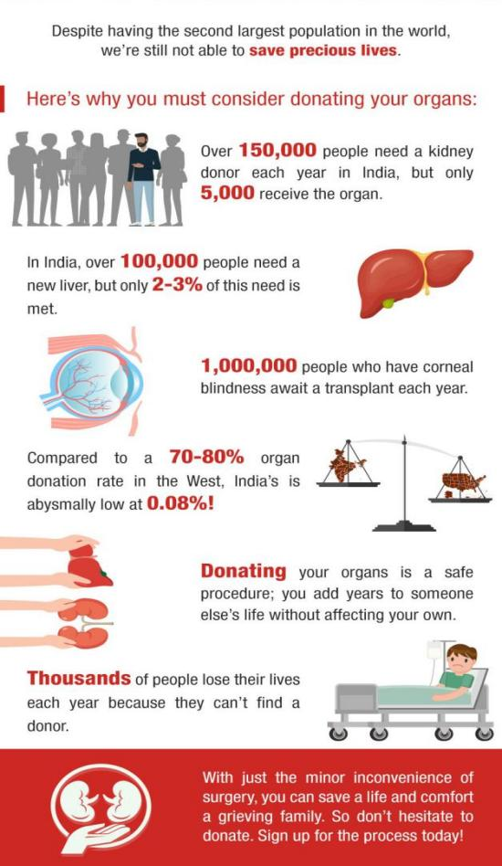

Figure 1: Overview on liver Transplantation

The first successful kidney transplant was performed in 1954 by Dr. Joseph Murray and his team at the Brigham and Women's Hospital in Boston, Massachusetts. This milestone marked the beginning of a new era in medicine, providing hope to countless patients facing renal failure. Following the success of kidney transplantation, efforts were directed towards transplanting other organs, including the heart, lungs, liver, and pancreas.
The advancements in surgical techniques, immunosuppressive medications, and organ preservation methods have contributed to the growth of organ transplantation as a viable treatment option for a wide range of medical conditions. Organ transplantation has since become an established therapeutic modality, offering improved quality of life and extended survival for recipients. However, despite its success, organ transplantation faces significant challenges, one of the most pressing being the shortage of donor organs. The demand for organs far exceeds the supply, leading to prolonged waiting times and, tragically, the loss of lives while awaiting transplantation. This scarcity of organs underscores the critical need for innovative approaches to increase the availability of viable donor organs. Additionally, the success of organ transplantation relies heavily on effective organ preservation methods. Once removed from the donor, organs must be preserved and transported to the recipient in optimal condition to ensure successful transplantation. Traditional preservation methods, such as cold storage, have been the cornerstone of organ preservation for decades. While effective for many organs, cold storage has limitations, particularly for organs prone to ischemic injury, such as the liver.

In recent years, there has been growing interest in developing advanced preservation techniques that better mimic the physiological conditions of the human body. Prolonged Normothermic Machine Perfusion (PNMP) has emerged as a promising alternative to traditional cold storage, offering the potential to improve organ viability and expand the pool of transplantable organs. In conclusion, organ transplantation has transformed from a pioneering procedure to a standard of care in modern medicine. However, challenges such as organ shortage and the need for improved preservation methods persist. Through ongoing research and innovation, the field continues to evolve, offering hope for improved outcomes and increased access to life-saving transplantation for patients worldwide.

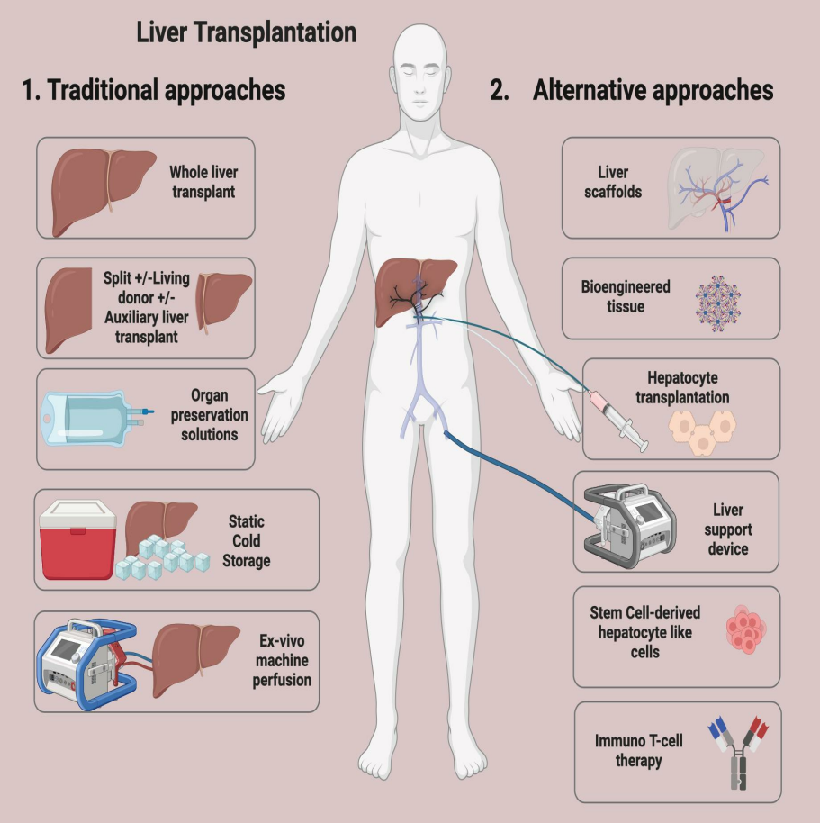

B. Limitations of Traditional Cold Storage for Liver Preservation:
Static cold storage (SCS) has been the cornerstone of liver preservation for transplantation for decades, but it is not without its limitations. While effective to a certain extent, SCS presents several drawbacks that can impact the viability and functionality of donor livers. These limitations include:

1. Time Sensitivity:
- SCS is time-limited, typically allowing for preservation of the liver for a maximum of 6 to 12 hours before transplantation.
- Continuation of metabolic activity during SCS leads to the depletion of energy stores, such as adenosine triphosphate (ATP), within hepatocytes, which compromises cellular function and viability over time.
- Prolonged ischemia during SCS can result in cellular injury, mitochondrial dysfunction, and eventual cell death, contributing to poor post-transplant liver function.

2. Loss of Cellular Function:
- The static nature of cold storage fails to adequately address the metabolic demands of the liver, leading to progressive cellular dysfunction and damage.
- Cold-induced ischemia slows metabolic processes but does not halt them entirely, leading to ongoing cellular deterioration during preservation.

3. Risk of Ischemia-Reperfusion Injury (IRI):
- Upon reperfusion of the liver during transplantation, ischemia-reperfusion injury (IRI) occurs due to the restoration of blood flow and oxygen delivery to the organ.
- Prolonged cold ischemia exacerbates the severity of IRI, resulting in oxidative stress, inflammation, and endothelial dysfunction, which can negatively impact graft survival and function post-transplantation.

4. Inadequate Assessment of Organ Viability:
- SCS does not provide real-time assessment of organ viability or function during preservation.
- Evaluation of the quality of donor livers is typically based on subjective assessments and static parameters, such as visual inspection and cold ischemia time.
- Lack of dynamic monitoring during cold storage may result in the transplantation of marginal or suboptimal grafts, increasing the risk of post-transplant complications and graft failure.
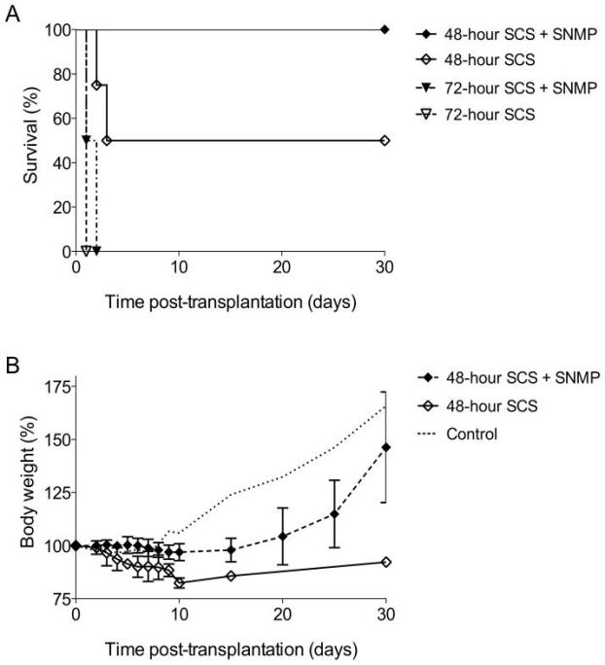

Figure 2: Transplantation success rate
C. Introduction to Prolonged Normothermic Machine Perfusion (PNMP):

Static cold storage (SCS) has long served as the standard method for organ preservation in transplantation. Despite its widespread use, SCS has inherent limitations, including the persistence of anaerobic metabolism and the inability to accurately assess organ quality and viability. These shortcomings have prompted the exploration of alternative preservation techniques, such as normothermic machine perfusion (NMP), to improve outcomes in organ transplantation.

- Rationale for Prolonged Normothermic Machine Perfusion:
- While SCS reduces metabolic activity, it does not completely halt cellular processes, leading to ongoing intracellular changes and compromising organ function over time.
- The limited storage time and challenges in assessing organ quality during SCS underscore the need for alternative preservation strategies.
- Ex situ NMP represents a promising approach that maintains organs at body temperature while supplying oxygen and nutrients, creating an environment conducive to aerobic metabolism and cellular function.

2. Advantages of NMP:
- NMP offers several advantages over SCS, including the ability to assess organ viability and function before transplantation.
- By providing continuous perfusion and monitoring, NMP allows for real-time evaluation of organ quality, potentially improving the selection of suitable donor organs.
- This approach is particularly relevant for extended criteria donor (ECD) organs, which may have marginal viability and require careful assessment before transplantation.

3. Evidence Supporting Prolonged NMP:
- Recent studies, including a European randomized trial by Nasralla et al., have demonstrated the safety and potential benefits of NMP over SCS in liver transplantation.
- Notably, Nasralla et al. reported ameliorated consequences of ischemia-reperfusion injury and improved outcomes with NMP compared to SCS.
- While the median duration of NMP in this trial was 9 hours, there is growing interest in exploring prolonged NMP beyond 24 hours to facilitate liver repair and regeneration.

4. Recent Advances in Prolonged NMP:
- Advanced perfusion devices capable of prolonged NMP for up to a week or longer have been developed, showing preserved viability in experimental models.
- The first clinical transplantation of a donor liver after 3 days of ex situ NMP was recently reported by the Zürich group, demonstrating the feasibility and safety of prolonged perfusion.

5. Key Considerations and Future Directions:
- While promising, prolonged NMP poses technical challenges and requires sophisticated perfusion systems.
- Further research is needed to optimize perfusion protocols, assess long-term outcomes, and explore the potential for organ repair and regeneration during extended NMP.

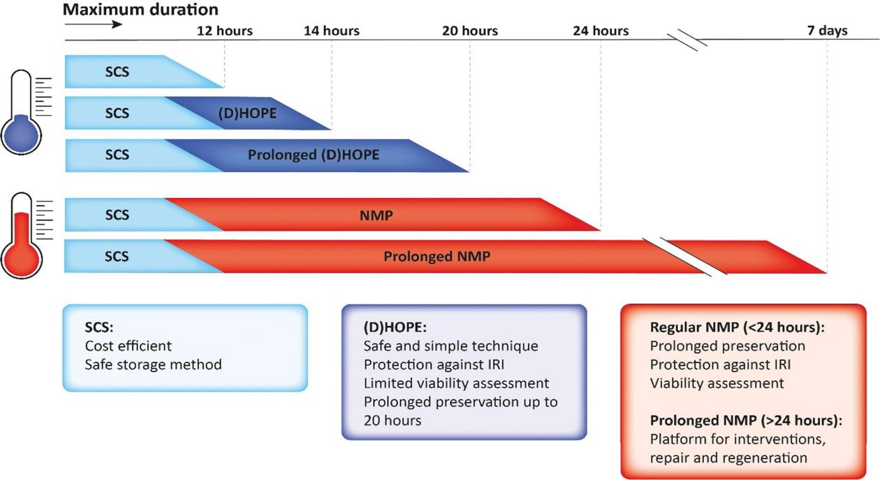
Figure 3: Effect of temperature in preservation

D. Importance of Prolonged Normothermic Machine Perfusion (PNMP) in Expanding the Pool of Viable Livers for Transplantation:

Normothermic machine perfusion (NMP) has emerged as a promising technique in liver transplantation, offering a tool for assessing organ viability and improving outcomes for both donors and recipients. Prolonged NMP (PNMP) holds particular significance in expanding the pool of viable livers for transplantation, as evidenced by several clinical trials and ongoing research endeavors.

1. Assessment of Organ Viability:
- NMP provides a platform for assessing liver viability pre-transplantation by maintaining physiological metabolism and function.
- Key parameters such as lactate clearance, transaminases, glucose metabolism, acid-base balance, bile production, and bile composition serve as markers of organ viability during NMP.
- The ability to evaluate viability allows for the selection of high-risk or discarded livers, potentially increasing the number of organs available for transplantation.

2. Clinical Trials and Evidence:
- Several clinical trials have demonstrated the safety and feasibility of NMP in liver transplantation, paving the way for its adoption in clinical practice.
- Studies by Ravikumar et al., Selzner et al., Bral et al., Nasralla et al., Liu et al., and Ghinolfi et al. have reported favorable outcomes with NMP, including comparable graft survival rates to traditional static cold storage (SCS).
- The randomized controlled trial by Nasralla et al. showed differences favoring NMP in reducing reperfusion syndrome and peak transaminases, highlighting the potential benefits of this preservation method.

3. Role in Expanding Donor Pool:
- PNMP offers the opportunity to utilize marginal or extended criteria donor (ECD) organs that may not be suitable for transplantation with traditional preservation methods.
- By assessing and potentially revitalizing marginal organs, PNMP has the potential to expand the pool of viable livers for transplantation, addressing the critical shortage of donor organs.

4. Ongoing Research and Future Directions:
- Ongoing clinical trials are investigating the role of PNMP in liver graft preservation, with a focus on optimizing protocols, assessing long-term outcomes, and expanding the use of NMP to different donor populations.
- Advanced perfusion devices and novel perfusion solutions continue to be developed, offering opportunities to further enhance the efficacy and feasibility of PNMP.
- Future research endeavors aim to elucidate the mechanisms underlying organ repair and regeneration during prolonged NMP, paving the way for innovative strategies to maximize organ utilization and improve transplant outcomes.

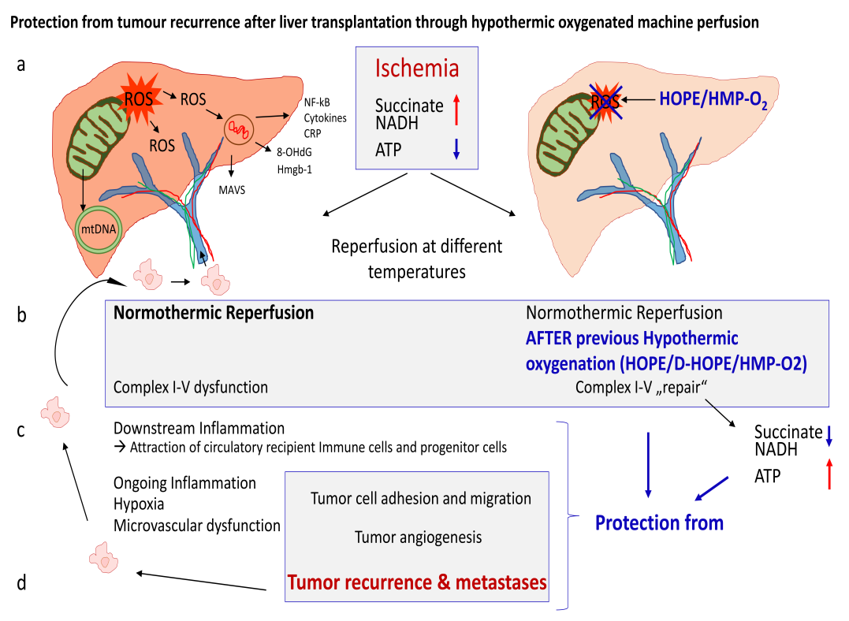

Figure 4: Internal process of PNMP

- DEVELOPMENT OF PNMP

- Evolution from traditional cold storage to normothermic machine perfusion

The shortage of viable organs for liver transplantation has prompted the exploration of innovative strategies to augment the donor pool. Despite the success of split liver transplantation, challenges persist, including technical complexities and a shortage of suitable grafts for splitting. Factors such as increased donor age and comorbidities, along with the global rise in obesity, have expanded the pool of marginal organs, including steatotic liver grafts. This disparity between organ demand and supply necessitates the development of rescue strategies for marginal organs or the expansion of the deceased donor pool.

Traditional preservation methods, such as static cold storage (SCS), have limitations, particularly for extended-criteria donor (ECD) organs, which are more susceptible to ischemia-reperfusion injury and associated complications. The current paradigm of SCS, characterized by sudden rewarming, often results in significant organ damage compared to healthy livers. Despite early experiments with continuous perfusion after organ retrieval, the advent of cold storage became predominant due to favorable outcomes in liver transplantation.

However, the increasing availability of marginal and ECD organs has led to a shift towards more sophisticated preservation techniques, with the reintroduction of machine perfusion (MP) marking a notable evolution in liver transplantation. MP encompasses various dynamic perfusion and preservation methods aimed at preserving and potentially enhancing ECD organs while assessing graft viability before transplantation.

Two primary variations of MP have emerged in clinical practice: normothermic MP (NMP) and sub-normothermic/hypothermic MP (SNMP/HMP). NMP involves perfusing the liver with oxygenated perfusion solution at normal body temperature, mimicking physiological conditions. In contrast, SNMP/HMP utilizes red blood cell-free perfusate with physically dissolved oxygen at sub-normothermic or hypothermic temperatures. Both approaches aim to prevent organ deterioration following retrieval and ischemia-reperfusion injury.

Recent advancements in NMP have demonstrated its feasibility and safety in clinical practice, with studies showing reduced graft damage compared to SCS, decreased discard rates, and improved outcomes for donor livers. NMP allows for near-physiological metabolism and synthetic liver function, facilitating pre-transplant assessment of organ viability and integrity.

The protective effects of NMP extend beyond minimizing tissue ischemia, potentially involving beneficial effects on sinusoidal endothelium and ATP reloading. Despite the promising results, challenges remain in standardizing indications for MP use and determining optimal protocols for different donor organs. Prospective, randomized clinical trials comparing MP with SCS, particularly NMP with SNMP/HMP, are needed to establish robust data guiding the selection of organs for MP and improve transplant outcomes.

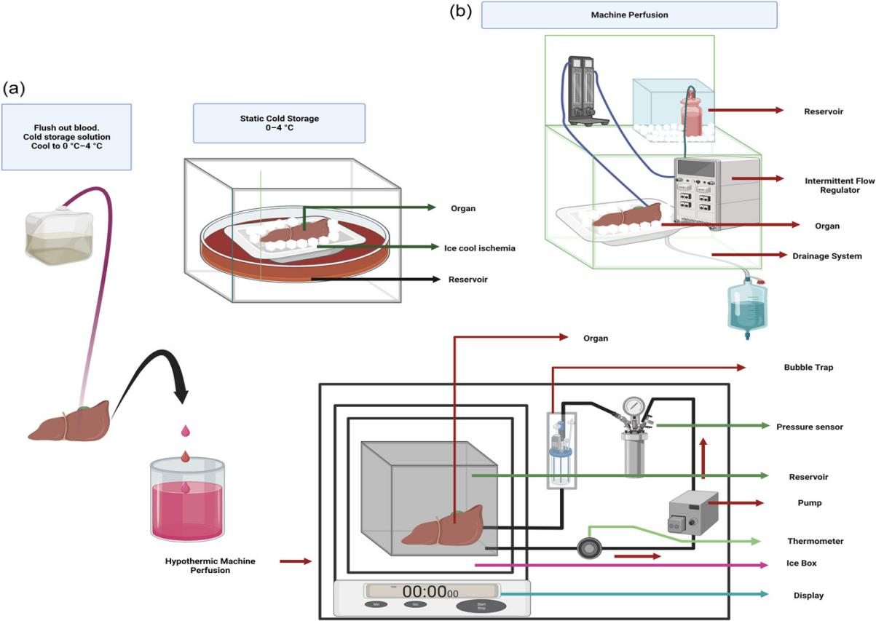
Figure 5: Block Diagram of PNMP
B. Principles underlying Prolonged Normothermic Machine Perfusion (PNMP):

- Maintenance of Physiological Conditions:
PNMP aims to recreate the physiological environment of the human body by maintaining the donor liver at normal body temperature (around 37°C). This allows for the continuation of near-normal metabolic activity and cellular function, mimicking conditions within the body.

- Continuous Oxygenation and Nutrient Supply:
PNMP involves perfusing the donor liver with a specialized preservation solution containing oxygen and nutrients. This continuous oxygenation and nutrient supply ensure that the liver receives essential elements required for cellular function, including energy production and synthetic activities.

- Dynamic Perfusion:
Unlike static cold storage, which involves immersing the organ in a cold solution, PNMP utilizes dynamic perfusion. The donor liver is connected to a machine perfusion system that circulates the preservation solution through the liver's blood vessels, ensuring uniform distribution of oxygen and nutrients and facilitating waste product removal.

- Assessment of Organ Function:
PNMP provides an opportunity for real-time monitoring and assessment of the donor liver's function and viability. Parameters such as bile production, oxygen consumption, glucose metabolism, and perfusate composition are continuously measured and analyzed to evaluate the organ's health status.

- Extended Preservation Time:
PNMP enables the extension of the preservation time beyond the limitations of static cold storage. By maintaining the liver in a functional state for an extended period, PNMP offers a window of opportunity for organ assessment, potential repair, and optimization before transplantation.

- Minimization of Ischemia-Reperfusion Injury:
PNMP aims to minimize ischemia-reperfusion injury, a common cause of organ damage during transplantation. By providing continuous oxygenation and nutrient supply, PNMP helps mitigate the consequences of ischemic stress and promotes the recovery of cellular function.

- Enhancement of Organ Utilization:
By improving the preservation and assessment of marginal or extended-criteria donor livers, PNMP has the potential to expand the pool of viable organs available for transplantation. This could help alleviate the critical shortage of donor organs and reduce waiting times for patients in need of liver transplantation.

C. Advantages of maintaining liver at a normal body temperature

- Preservation of Metabolic Integrity:
By perfusing the liver at physiological temperature (around 37°C), NMP allows for the preservation of metabolic integrity. Unlike in HMP, where cellular metabolism is significantly slowed down, NMP maintains metabolic activity close to normal levels. This ensures continuous ATP production, essential for cellular functions and viability.

- Optimized Energy Substrate Utilization:
NMP facilitates the utilization of energy substrates such as glucose and oxygen at a rate closer to that of the physiological state. This optimized energy substrate utilization supports cellular functions and prevents the depletion of ATP levels, reducing the risk of cellular damage and dysfunction.

- Mitigation of Ischemia-Reperfusion Injury (IRI):
Ischemia-reperfusion injury is a significant concern in organ transplantation, contributing to graft dysfunction and failure. NMP helps mitigate the consequences of IRI by maintaining continuous oxygenation and nutrient supply to the liver during preservation. This reduces the severity of oxidative stress and inflammatory responses associated with IRI.

- Enhanced Viability Assessment:
NMP provides an opportunity for real-time assessment of liver viability before transplantation. By maintaining the liver in a functional state and allowing continuous monitoring of metabolic parameters, NMP enables transplant teams to evaluate organ function and suitability for transplantation more accurately.

- Extended Preservation Time:
Unlike SCS, which is limited by storage time, NMP allows for an extended preservation period. This extended preservation time provides flexibility in organ allocation and transplantation scheduling, reducing the pressure to transplant organs quickly after retrieval.

- Potential for Organ Repair and Reconditioning:
NMP creates an optimal environment for organ repair and reconditioning before transplantation. The maintenance of physiological conditions and metabolic activity during perfusion may facilitate the recovery of cellular function and support mechanisms of tissue repair and regeneration.

- Improved Outcomes:
Clinical studies have shown promising outcomes with NMP, including reduced rates of primary non-function and early allograft dysfunction compared to SCS. By optimizing organ preservation and assessment, NMP has the potential to improve transplant outcomes and patient survival rates.

D. Objectives and Goals of Normothermic Machine Perfusion (NMP) in Liver Preservation:

- Enhanced Viability Assessment:
NMP provides a platform for assessing the viability and functional integrity of marginal donor livers before transplantation. By perfusing the liver at physiological temperature (37°C) and maintaining near-physiological metabolic and synthetic function, NMP allows real-time evaluation of organ suitability, reducing the risk of primary non-function (PNF) and early allograft dysfunction.

- Salvaging Marginal Organs:
With the increasing prevalence of marginal donor livers, NMP offers a means to salvage these organs for successful transplantation. Marginal livers, including those from older donors, donors after circulatory death (DCD), and livers with significant hepatic steatosis, can benefit from the physiological conditions provided by NMP, which may improve their resilience to ischemia-reperfusion injury (IRI) and enhance post-transplant outcomes.

- Extended Preservation Time:
Unlike static cold storage (SCS), which has limited preservation times, NMP allows for an extended preservation period. This extended preservation time provides flexibility in organ allocation and transplantation scheduling, reducing the pressure to transplant organs quickly after retrieval and potentially expanding the donor pool.

- Mitigation of Ischemia-Reperfusion Injury (IRI):
IRI is a significant contributor to graft dysfunction and failure in liver transplantation. NMP aims to mitigate the consequences of IRI by maintaining continuous oxygenation and nutrient supply to the liver during preservation. By minimizing oxidative stress and inflammatory responses associated with IRI, NMP can improve graft function and reduce the risk of complications post-transplantation.

III. MECHANISM OF PNMP

- Description of the perfusion machine and its components

1. Machine Perfusion (MP):
Machine perfusion (MP) represents a significant advancement in organ preservation techniques, offering precise control over perfusion conditions to optimize organ viability and function prior to transplantation. MP has been explored at different temperatures, with hypothermic machine perfusion (HMP) and normothermic machine perfusion (NMP) being the most widely studied clinically.

2. Hypothermic Machine Perfusion (HMP):
HMP involves perfusing the organ at low temperatures, typically between 4 and 8°C. This low temperature slows organ metabolism, reducing oxygen demand and cellular activity. HMP can be performed with or without active oxygenation (HOP), where oxygen is actively delivered to the organ to restore cellular energy stores and decrease the release of reactive oxygen species post-reperfusion. HOP aims to attenuate ischemia-reperfusion injury (IRI) by resuscitating mitochondria and replenishing cellular energy reserves.
The principle behind HMP is to generate oxidative energy (ATP) at a reduced rate through the electron transport system in mitochondria. This process helps maintain cellular viability and function during organ preservation. HMP has shown promising results in preclinical animal models and clinical trials, demonstrating its superiority over static cold storage (SCS) in preserving organ function and reducing post-transplant complications.

3. Normothermic Machine Perfusion (NMP):
NMP aims to mimic physiological conditions by perfusing the organ at or near body temperature (37°C) with oxygenated blood, nutrients, and medications. Unlike HMP, which slows organ metabolism, NMP facilitates normal aerobic metabolism of the graft, allowing for the evaluation of organ health and function.

NMP has several advantages over SCS and HMP, including the ability to assess organ viability in real-time, extend preservation times, and pretreat the organ with medications ex vivo. NMP has been successfully used to evaluate the viability of marginal grafts and optimize organ matching for transplantation.

4. Alternatives to Blood Products:
While blood-based perfusate has traditionally been used for NMP, alternatives such as acellular oxygen carriers have been explored to mitigate the risks associated with blood products, including immune-mediated responses and infectious transmission. Studies have shown promising results with alternative perfusates, such as Hemopure, a bovine hemoglobin-based oxygen carrier, demonstrating improved organ metabolism and function compared to traditional blood-based perfusates.

5. Clinical Trials and Studies:

Several clinical trials have investigated the efficacy of HMP and NMP in preserving organ function and reducing post-transplant complications. Studies have shown that HMP-treated livers exhibit less enzyme release after reperfusion compared to non-perfused livers, indicating improved preservation outcomes. Similarly, NMP has been shown to improve post-transplant outcomes by facilitating organ viability assessment and optimizing organ matching for transplantation.

Components Description:

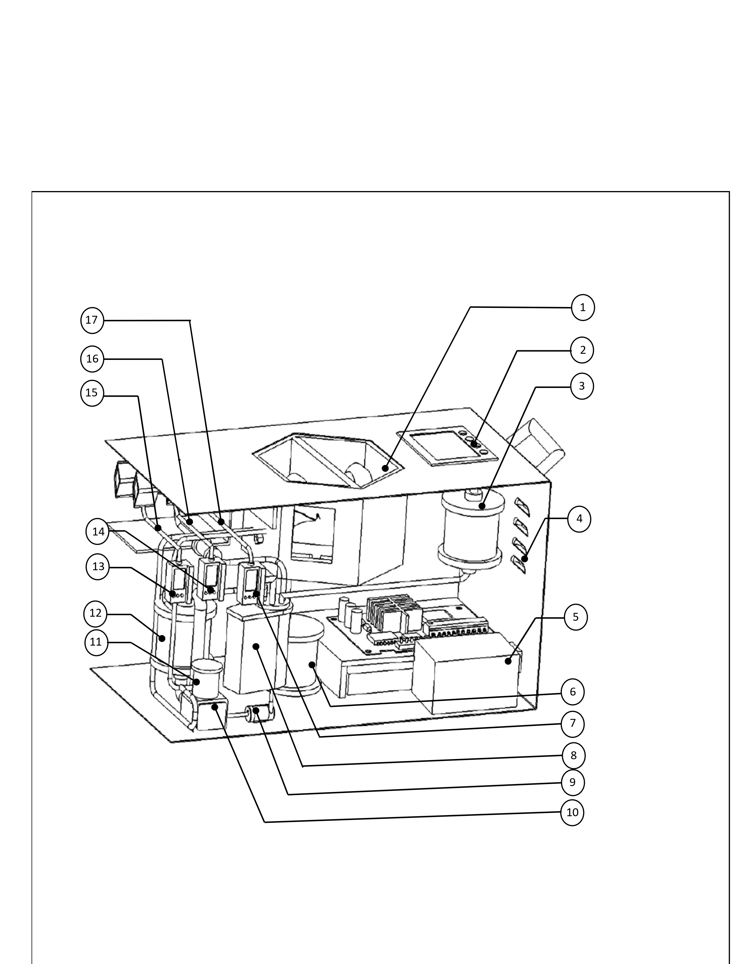

- Organ Basin:
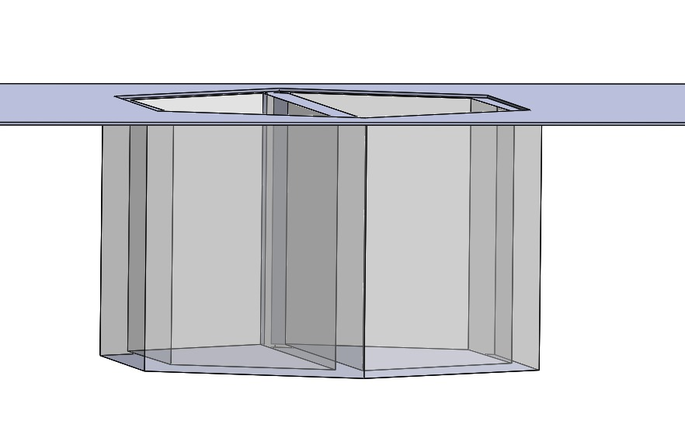

The purpose of the organ basin is to hold the organ, in this case, the kidney, safely and securely during transportation from the donor to the recipient. The organ basin is typically made of a sterile and biocompatible material to ensure that it does not interact negatively with the organ or preservation solution. It is designed to keep the kidney immersed in the preservation solution. During kidney transplantation, once the donor kidney has been removed from the donor's body, it is flushed with the preservation solution to remove blood and debris. The kidney is then placed in the organ basin, and the basin is filled with the preservation solution, completely submerging the organ. This immersion ensures that the kidney is kept in a cold, oxygenated environment, which slows down the organ's metabolic processes and helps preserve its functionality. The organ basin is usually sealed securely to prevent any leakage of the preservation solution during transportation. It also helps protect the kidney from physical trauma that could occur during transit.

- Display:
The purpose of the display is to show the essential parameters necessary for preserving the organ during Prolonged Normothermic Machine Perfusion. These parameters include oxygen levels, pressure, ATP results, and HPE parameters. Having this information displayed is highly beneficial for doctors as it enables them to monitor and care for the organ effectively, based on the indicated parameters.

- Cleanser Unit
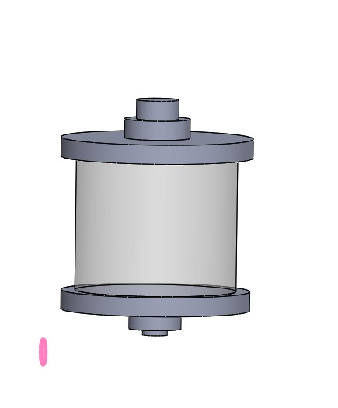

A cleanser unit refers to a component or system within the machine perfusion setup that is responsible for cleaning and filtering the organ basin before and after it is used to preserve the discarded human organ. The cleanser unit plays a crucial role in maintaining the quality of the organ basin and ensuring that it remains free from impurities, debris, and harmful substances. This is important because the organ basin is in direct contact with the discarded organ, and any contamination or buildup of toxins could negatively impact the viability and health of the organ during the preservation process.
The cleanser unit typically consists of filters and purification mechanisms that remove unwanted particles, bacteria, and other contaminants from the basin. This ensures that the organ basin remains oxygenated, sterile, and well-balanced with nutrients to support the organ's cellular function and viability. By employing a cleanser unit in the PNMP system, medical professionals can maintain optimal conditions for the organ throughout the preservation period, increasing the chances of successful transplantation and potentially expanding the pool of available organs for transplantation.

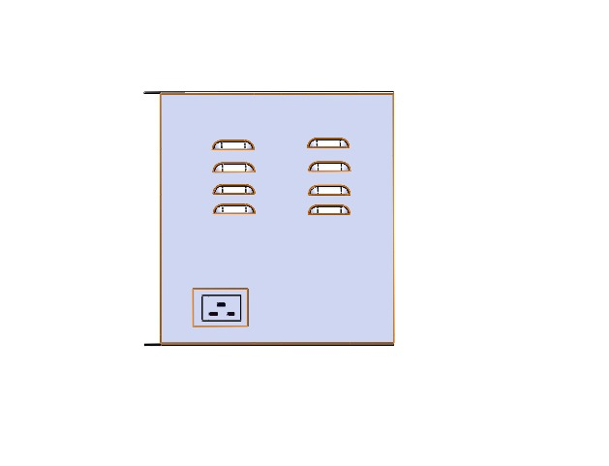
- Air Filters:

Air filters are often utilized to remove carbon dioxide and other waste gases from the perfusion system while providing a continuous supply of oxygen. These filters help maintain a controlled and sterile environment for the organ during the perfusion process. The filters ensure a continuous flow of oxygen into the perfusion system, enabling the organ to receive a constant supply of oxygenated blood or preservation solution, which is essential for its viability and function. As the discarded organ continues to metabolize during normothermic machine perfusion, it produces waste gases such as carbon dioxide. The air filters help remove these waste gases from the system to prevent their accumulation, maintaining optimal conditions for the organ.The air filters play a role in preventing the introduction of contaminants and pathogens into the perfusion system. This is particularly important to maintain a sterile environment for the organ, reducing the risk of infections and complications.

- PMS Unit

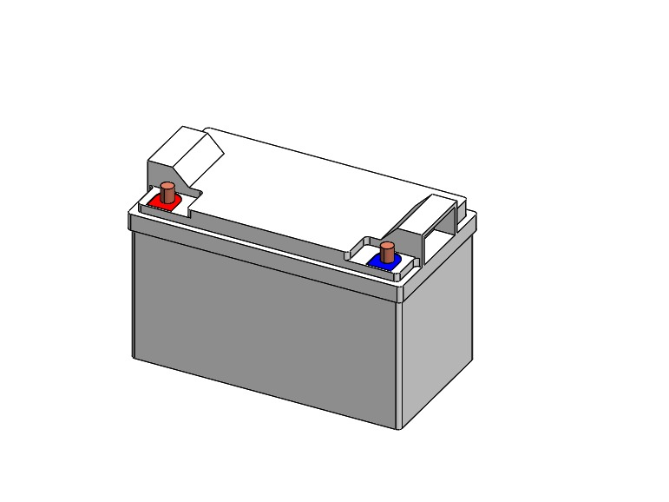

A power management system unit is component that is responsible for managing and supplying power to the machine perfusion system. The power management system unit is a critical part of the machine perfusion setup because it ensures a stable and reliable power supply to all the components and instruments involved in the process. It typically includes power sources, voltage regulators, circuit protection, and other electrical components to manage the power distribution and prevent damage to the system. A reliable power management system is essential during PNMP, as any power failure or instability could compromise the viability of the discarded organ and render it unsuitable for transplantation.

- Heaters :
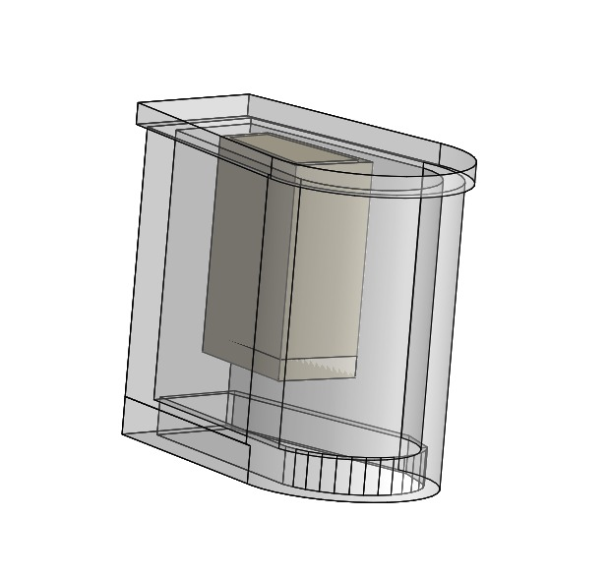

Kidney preservation kits are designed to keep the organs at a specific temperature during transportation from the donor to the recipient. The preservation solution used in these kits, such as University of Wisconsin (UW) solution or Euro-Collins solution, provides a cold and oxygenated environment to slow down the metabolic processes and preserve the kidney's viability.
The preservation solution itself is pre-chilled to a specific temperature and is intended to keep the kidney cold, typically between 0 to 4 degrees Celsius (32 to 39 degrees Fahrenheit). This helps to minimize the metabolic demand of the organ, extending its preservation time outside the body. Heating elements are generally not used in these kits because warming the kidney could accelerate metabolic processes, potentially leading to organ damage. The goal is to slow down cellular activity and prevent damage during transportation, rather than trying to revive the organ before transplantation.

- HA Pressure monitor
The HA pressure monitor is a device used to measure and monitor the pressure within the hepatic artery, which is the blood vessel responsible for supplying oxygen-rich blood to the liver. Monitoring the HA pressure during the perfusion process can provide valuable information about the vascular condition of the organ, as well as its response to the perfusion procedure. By closely monitoring the HA pressure, transplant teams can gain insights into the organ's function, perfusion stability, and potential areas of concern. Abnormalities in the HA pressure during the perfusion process may indicate issues such as vascular resistance, vascular injury, or potential problems in the blood supply to the liver. Having this real-time information can aid transplant surgeons and medical professionals in making critical decisions about the viability and suitability of the organ for transplantation.

- Reservoir:
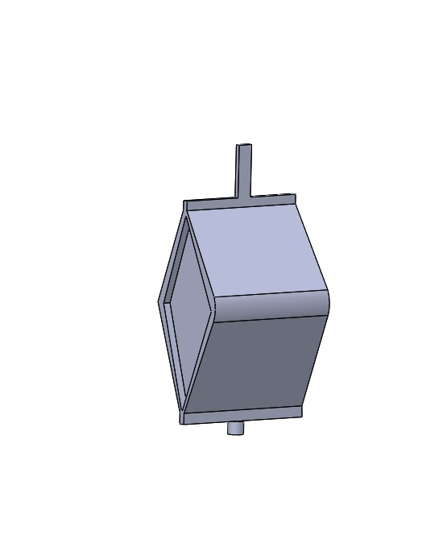

A reservoir typically refers to a container or compartment within the preservation kit that holds the preservation solution. This reservoir is specifically designed to store and protect the kidney during transportation from the donor to the recipient, ensuring the organ remains in a cold and oxygenated environment. When a kidney is procured for transplantation, it is removed from the donor's body and placed in the preservation solution. The preservation solution, such as University of Wisconsin (UW) solution or Euro-Collins solution, is a specialized fluid that helps to preserve the kidney by slowing down its metabolic processes and minimizing damage during transportation.
The kidney is usually placed in a sterile bag or container, and this bag or container serves as the reservoir where the preservation solution is held. The reservoir is then sealed and kept at a specific temperature. The use of a reservoir in kidney preservation kits is critical for maintaining the organ's viability and ensuring its successful transplantation into the recipient. The reservoir helps to create an optimal environment for the kidney during the transportation period, which can sometimes involve long distances or extended periods of time.

- Rotaflow pump

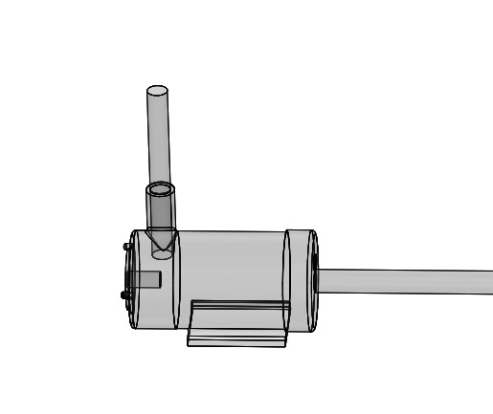

The Rotaflow pump is a specialized medical device designed for extracorporeal circulation, specifically in extracorporeal life support (ECLS) systems such as extracorporeal membrane oxygenation (ECMO). It operates using the principle of centrifugal force to facilitate the movement of blood or other fluids through the pump. At the core of the Rotaflow pump is a spinning motor that rotates at high speeds. This motor is connected to an impeller or rotor, which is a set of curved blades. As the motor spins, the impeller also rotates rapidly. When the impeller rotates, it creates centrifugal force. Centrifugal force is an outward force experienced by an object moving in a circular path. In the case of the Rotaflow pump, this force pushes the blood or fluid away from the center of rotation, towards the outer edge of the impeller. Blood or other fluids are introduced into the pump at the center, where the impeller is located. As the impeller spins, the centrifugal force generated pushes the blood towards the outer edge of the impeller. Near the outer edge of the impeller, the pump is designed with an outlet that directs the flow of blood or fluid away from the pump. As the blood moves towards the outlet, it gains energy from the spinning impeller, and this energy transfer helps propel the blood or fluid out of the pump and into the patient's circulatory system. The Rotaflow pump is commonly used in ECMO and other ECLS systems, where it assists or temporarily replaces the function of the heart and/or lungs. It allows the patient's blood to be continuously circulated, oxygenated, and filtered, providing support to vital organs during critical conditions when the patient's own circulatory or respiratory systems are compromised. The Rotaflow pump's efficient and continuous blood flow management is crucial in ECLS scenarios, as it helps maintain tissue perfusion, oxygenation, and carbon dioxide removal, supporting the patient's overall stability and recovery. Its precise design and performance make it a valuable tool in modern medical practice for managing critically ill patients in need of extracorporeal life support.

- IV fusion pump
An infusion pump is a medical device that delivers fluids, including medications, nutrients, or other therapeutic solutions, into a patient's body in a controlled and precise manner. In the context of PNMP, the IV fusion pump could be used to deliver a carefully controlled solution to the preserved organ, ensuring it receives essential nutrients and medications to maintain its function during the perfusion process.

- Oxygenator:
The preservation solution is usually oxygenated before it is used to flush and store the kidney. This is done to ensure that the organ receives the necessary oxygen while outside the body, despite not being actively perfused as it would be inside a living organism. The oxygenation process involves bubbling oxygen or another gas mix through the preservation solution before it is used to flush and store the kidney. This helps maintain the viability of the kidney during the preservation period.
During transportation, the kidney is typically stored in a sealed container or bag with an oxygenated preservation solution. While the preservation solution is oxygenated, it is not an oxygen-delivery system like an oxygenator used during surgical procedures involving the heart and lungs. The kidney is not actively perfused with oxygenated blood during preservation; instead, it relies on the oxygen present in the preservation solution.

- Cytokine filters

Cytokine filters are a type of filtration device designed to remove cytokines and other inflammatory mediators from the bloodstream. Cytokines are small proteins that play a crucial role in cell signaling and the immune response. However, excessive and uncontrolled release of cytokines can lead to a harmful immune system reaction, known as a cytokine storm, which can cause significant tissue damage and organ dysfunction. The use of cytokine filters in PNMP will potentially be explored to mitigate the impact of cytokine release during the preservation process. By removing excessive cytokines and inflammatory mediators from the perfusate, the filters may help reduce inflammation and protect the organ from damage, potentially improving its post-transplant outcomes.

- PV Pressure monitor
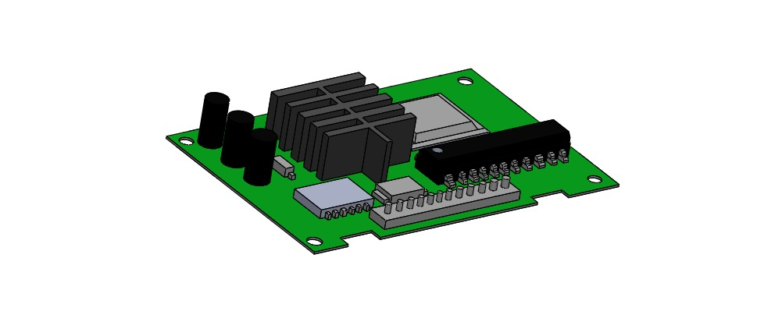

A PV pressure monitor would likely be used to measure the pressure within the portal vein, which is a major vein that carries blood from the digestive organs to the liver. Monitoring the PV pressure during machine perfusion can provide valuable information about the condition and function of the organ being preserved. Changes in PV pressure could indicate vascular resistance, congestion, or other issues that may affect the viability and suitability of the organ for transplantation. By continuously monitoring the PV pressure, medical professionals can make real-time adjustments to the perfusion parameters, including flow rates and solution compositions, to optimize the preservation process and maintain the organ in the best possible condition for transplantation.

- Medication Probe:
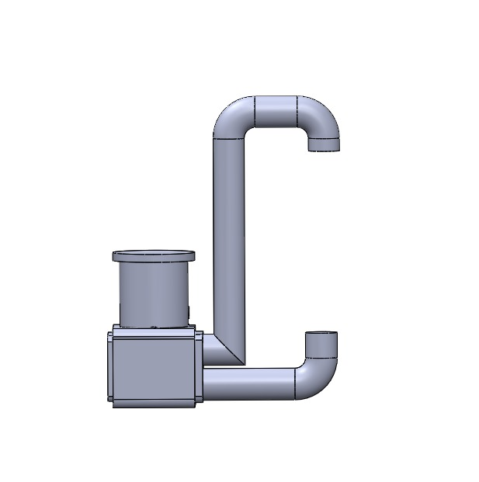

It is used to dilate blood vessels and improve blood flow through the organ. This can help maintain organ function and reduce the risk of ischemia (inadequate blood supply) during PNMP. Drugs that prevent blood clotting can be used during PNMP to prevent blood clots from forming within the organ or the machine's tubing, which could impair the perfusion process. These medications may be used to reduce oxidative stress and protect the organ from damage caused by free radicals generated during the perfusion process. Anti-inflammatory Agents: Drugs that help reduce inflammation may be administered to minimize inflammation-related damage to the organ during PNMP.

- PV Infusion
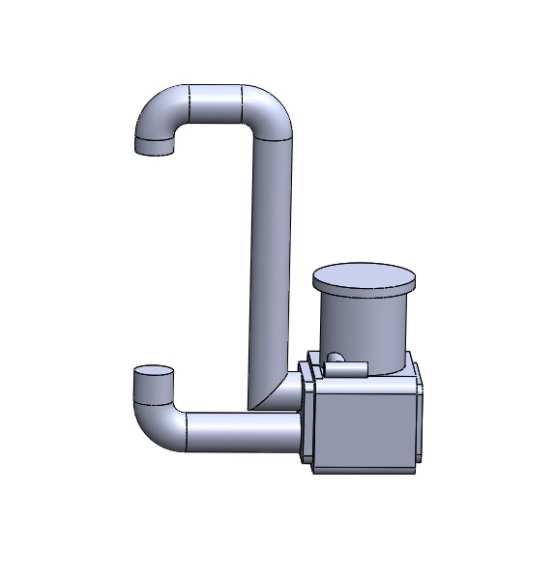

The discarded human organ is connected to a perfusion machine through its blood vessels, including the portal vein. The portal vein supplies blood to the liver and intestines and is an essential vessel to monitor during liver perfusion. By infusing a preservation solution through the portal vein, the perfusion machine can help deliver oxygen, nutrients, and other essential substances to the organ, keeping it functioning optimally during the preservation process. The infusion of a preservation solution or medications directly into the veins of the discarded organ. This method allows for precise delivery of substances into the organ to maintain its function and viability during the PNMP process.

- HA Infusion
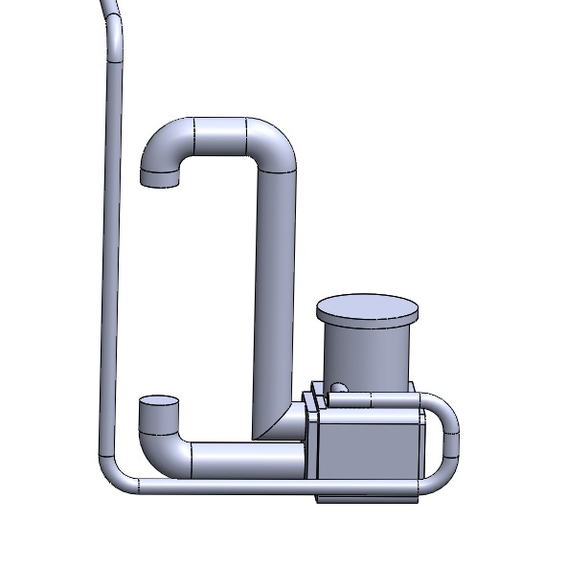

Hyaluronic Acid is a natural substance found in the body that has been used in various medical applications, including in some surgical and regenerative medicine procedures. It will help to reduce inflammation and oxidative stress during organ preservation, potentially improving organ quality and function. It is known for its ability to promote tissue repair and regeneration. In the context of organ transplantation, it might aid in the recovery and restoration of damaged tissues within the organ. It is a hydrophilic molecule, meaning it attracts and retains water. This property can help maintain tissue hydration during PNMP, which is crucial for preserving organ integrity.
- Auxiliary Port
This port will allow medical professionals to take samples of the perfusion solution and the organ's perfusate to assess the organ's metabolic status and overall condition during the perfusion process. It will be used to administer medications or other agents directly into the perfusion circuit to assess their effects on the organ or to provide targeted treatments. It is used to connect various monitoring devices to measure parameters such as oxygen levels, pressure, temperature, or other relevant indicators to ensure optimal perfusion conditions. It enables medical professionals to conduct biopsies or other assessments of the organ during the perfusion process to evaluate its quality and function.
- Process of connecting and perfusing the donated liver
Liver transplantation is a life saving treatment for selected patients with end-stage liver disease, primary liver cancer and fulminant hepatic failure. The incidence of liver disease has risen by 500% over the last 4 decades., However, access to transplantation is limited by the shortage of donor organs. As a consequence, 240 patients (19%) waiting for liver transplantation in the United Kingdom either died or were removed from the waiting list in 2016–2017. Data from the United States shows a similar pattern, comprising 32% of those listed for transplant (3629 patients) within 3 years of listing. The demand for liver grafts has driven the wider use of extended criteria donors. However, these are associated with an increased risk of primary non-function or delayed failure, and the acceptance of these higher-risk organs varies widely. Because of these inferior outcomes, and the difficulty of predicting organ viability, many potential donor organs remain unutilised. The high waiting list mortality justifies the utilisation of more marginal grafts, but current practice requires risk mitigation by matching high-risk livers to lower-risk recipients to achieve patient survival rates that are acceptable. Furthermore, the determination of suitability of a graft for transplantation largely depends on a surgeon’s subjective assessment of the graft’s appearance, using criteria that are known to be unreliable.
Organ preservation currently relies upon cooling to ice temperature to reduce cellular metabolism, and infusing specialist solutions to limit cellular damage. Oxygen deprivation and accumulation of by-products of anaerobic metabolism limit the duration of storage and result in ischaemia–reperfusion injury at the time of implantation. This process is more severe in marginal organs. Normothermic machine perfusion (NMP) has been shown to reduce preservation-related graft injury compared to static cold storage in transplantable livers, according to current selection criteria, in a prospective European trial, which also demonstrated increased utilisation of organs. In NMP, the liver is supplied with oxygen, nutrients and medication at physiological temperature and pressures, maintaining conditions that support homoeostasis, normal metabolic activity and objective assessment of function in real-time. Experimental data have shown that end-ischaemic NMP facilitates replenishment of adenosine triphosphate and glycogen levels. Based on increasing clinical experience, viability criteria have emerged; these are objective parameters, measurable during NMP. Whilst the feasibility of this approach has been demonstrated in a proof-of-concept series, it has not been validated in a rigorous clinical trial.
We therefore conducted this prospective, non-randomised, adaptive phase 2 trial in a large single centre, to evaluate the potential of NMP to provide objective assessment of the viability of livers currently deemed unsuitable for transplantation, and to transplant those that met predetermined criteria. The primary clinical objective underlying this project was the increased and safe utilisation of livers which are currently discarded.
The trial demonstrates that viability testing with NMP is feasible, and the objective assessment enables successful transplantation of 71% of perfused discarded livers, with 100% 90-day patient and graft survival. The intervention does not seem to prevent the development of non-anastomotic biliary strictures in livers donated after circulatory death (DCD) with prolonged donor warm ischaemic times.

Donor liver characteristics and liver biopsy features
In 8 (26%) donors, the liver was the only procured organ. All discarded donor livers entered in the study satisfied one or more of the inclusion high-risk criteria. The livers enroled in the trial consisted of 17 organs donated after brainstem death (DBD) and 14 DCD. Many of these organs looked grossly suboptimal, with some degree of steatosis, capsular fibrosis or rounded edges with multifactorial reasons for discard, that was captured by the donor risk index (DRI) > 2.0 in 22 (71%) livers, with the median DRI 2.2 (1.9–2.9). Detailed characteristics are shown in Table 1 and Supplementary Table 1. The transplanted livers were typically smaller than non-viable ones (1.7 vs. 2.0 kg, p = 0.015; Kruskal–Wallis test), with lower peak pre-mortem donor liver enzyme levels. The median static cold storage time before starting NMP was 7 h:44 min (6:29–10:25). Only 3 (10%) livers were included in the trial primarily for macrosteatosis >30%, (50%, 80% and 60% macrovesicular steatosis combined with 11 h:55 min, 12 h:00 min and 6 h:15 min cold ischaemia, respectively). Glycogen content and steatosis degree did not predict the viability assessment results. The detailed histological finding of each study liver is provided in Supplementary Table 2.

Table 1
Donor and liver characteristics (median, interquartile range).
Donor characteristics | Non-transplanted (n = 9) | Transplanted (n = 22) | Overall (n = 31) | p Valuea
Age in years (range) | 57 (52–60) | 56 (45–65) | 57 (45–63) | 0.948
Sex—n (%) |  |  |  | 0.696
Female | 3 (33.3) | 10 (45.5) | 13 (41.9)
Male | 6 (66.7) | 12 (54.5) | 18 (58.1)
Height (cm) | 174 (172–186) | 170 (165–175) | 170 (166–175) | 0.038
Bodyweight (kg) | 79 (75–88) | 81 (70–90) | 80 (70–90) | 0.662
Body mass index (kg/m2) | 28.7 (24.8–29.1) | 29.3 (26.5–32.4) | 28.7 (24.8–32.1) | 0.372
Liver weight (kg) | 2.0 (1.8–2.4) | 1.7 (1.3–1.9) | 1.8 (1.4–2.0) | 0.015
Peak alanine transferase (IU/ml) | 323 (92–1143) | 48 (33–159) | 83 (36–287) | 0.034
Peak gamma-glutyl transferase (IU/ml) | 169 (107–335) | 80 (42–111) | 92 (57–203) | 0.012
Peak bilirubin (µmol/L) | 10 (10–18) | 11 (7–22) | 11 (8–22) | 0.768
History of excessive alcohol use—n (%) | 5 (55.6) | 5 (22.7) | 10 (32.3) | 0.105
Diabetes mellitus—n (%) | 0 (0.0) | 2 (9.1) | 2 (6.5) | 1.000
Donor type—n (%) |  |  |  | 1.000
Donor after brain death | 5 (55.6) | 12 (54.5) | 17 (54.8)
Donor after circulatory death | 4 (44.4) | 10 (45.5) | 14 (45.2)
Donor warm ischaemic time (min)b | 20.0 (15.5–22.5)b n = 4 | 22.5 (19.0–35.0)b n = 10 | 21.0 (19.0–25.0)b n = 14 | 0.394
Quality of in situ flush—n (%) |  |  |  | 0.016
Poor | 3 (33.3) | 4 (18.2) | 7 (22.6)
Fair | 4 (44.4) | 1 (4.5) | 5 (16.1)
Good | 2 (22.2) | 17 (77.3) | 19 (61.3)
Cold ischaemic time (min) | 550 (436–715) | 452 (389–600) | 464 (389–625) | 0.277
Donor risk indexc | 2.3 (2.0–2.7) | 2.1 (1.9–3.0) | 2.2 (1.9–2.9) | 0.728
Histological steatosis assessment—n (%)d |  |  |  | 0.113
<30% steatosis | 2 (22.2) | 13 (59.1) | 15 (48.4)
>30% steatosis | 7 (77.8) | 9 (40.9) | 16 (51.6)
Inclusion criteriae
Donor risk index >2.0 | 6 (66.7) | 16 (72.7) | 22 (71.0) | 1.000
Steatosis principal reason to discardf | 1 (11.1) | 2 (9.1) | 3 (9.7) | 1.000
High liver transaminases | 3 (33.3) | 2 (9.1) | 5 (16.1) | 0.131
Balanced risk score >9 | Not applicable | 2 (9.1) | Not applicable | Not applicable
Extensive cold ischaemic time | 2 (22.2) | 3 (13.6) | 5 (16.1) | 0.613
Extensive donor warm ischaemic time | 0 (0.0) | 3 (13.6) | 3 (9.7) | 0.537
Poor in situ flush | 3 (33.3) | 4 (18.2) | 7 (22.6) | 0.384
Perfusion criteria
Lactate clearance <2.5 mmol/L | 3 (33.3) | 22 (100.0) | 25 (80.6) | <0.0001
pH ≥ 7.30 | 3 (33.3) | 19 (86.4) | 22 (71.0) | 0.007
Presence of bile production—n (%) | 6 (66.7) | 18 (81.8) | 24 (77.4) | 0.384
Bile volume (mL) | 10 (2–18) | 60 (15–99) | 46 (2–90) | 0.100
Glucose metabolism | 4 (44.4) | 20 (90.9) | 24 (77.4) | 0.012
Vascular flows criteria met | 9 (100) | 22 (100) | 31 (100) | Not applicable
Homogenous liver perfusion | 7 (77.8) | 22 (100.0) | 29 (93.5) | 0.077

Perfusion parameters assessment
During the NMP procedure 25 livers quickly recovered metabolic activity and cleared lactate to the target level (details provided in Fig. 4). A biopsy of a suspicious donor colonic lesion confirmed malignancy, making one liver unsuitable for transplantation, after meeting the viability criteria. In three livers, criteria were initially met, however, metabolic function thereafter deteriorated within the first 4 h, with increasing lactate. In two cases the transplant procedure was not commenced and the livers were discarded. In the third, the explant had begun, and the procedure continued. Overall, 22 (71%) livers met the viability criteria and were transplanted following a median total preservation time of 17 h:53 min (16:17–21:48; Table 2).

- Composition of the preservation solution and its role

Normothermic Machine Perfusion
NMP aims to recapitulate an environment that mimics the human body, providing the liver with oxygen and nutrition at 37 °C. Principal constituents include a blood reservoir, pump(s) (some circuits comprise two pumps, representing portal venous and hepatic arterial flow), an oxygenator and heat exchanger. Currently, the devices which are either commercially available or being used in clinical trials include the following: the OrganOx metra (OrganOx Ltd., Oxford, UK), the Liver Assist (Organ Assist, Gronigen, the Netherlands), OCS™ Liver System (Transmedics, Andover, Massachusetts) and the Cleveland NMP circuit (Cleveland Clinic, Cleveland, Ohio). These devices mainly differ in the cannulation method (closed circuit vs open drainage), arterial flow (pulsatile vs continuous), portability and degrees of automation (pertaining to vascular pressures, flow rates and blood gas regulation). In terms of normothermic preservation, most published clinical outcome data and expertise lie with the OrganOx metra (OrganOx Ltd., Oxford, UK) device. This technology uses a normothermic suspension of red cells in a colloid to perfuse the liver in a fully cannulated system. Briefly, the perfusate is pumped out of the inferior vena cava using a centrifugal pump, heated and oxygenated. It is then diverted either to the hepatic artery through a high-pressure, low-flow system or to the soft-shell reservoir which feeds the portal vein via a high-flow, low-pressure system. Constant blood gas analysis enables monitoring and control of pO2 and pCO2 levels, facilitating maintenance of acid-base homeostasis. Continuous infusions ensure sufficient vasodilation, protection against coagulation and the provision of an environment that enables near-physiological metabolic and synthetic liver function.

IV. APPLICATIONS OF PNMP

Preservation of marginal or damaged organs
Preservation of marginal or damaged organs is crucial for expanding the donor pool in transplantation. Marginal organs encompass those sourced from older donors, those retrieved after circulatory death (DCD), and organs presenting pre-existing damage or pathology. Conventional cold storage methods often fall short in adequately preserving marginal organs, heightening the risk of graft failure post-transplantation. However, machine perfusion techniques, such as normothermic or hypothermic machine perfusion, present promising alternatives for enhancing the preservation of these organs. By enabling continuous assessment and support of organ function, machine perfusion holds the potential to significantly improve outcomes for transplant recipients, ultimately addressing the critical shortage of viable organs available for transplantation.

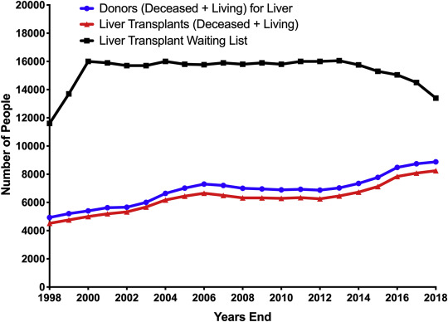
- Expansion of the donor liver pool
Liver transplantation has emerged as a lifesaving operation for patients fortunate enough to receive a donated organ. Today, the 1‐year unadjusted survival rate for a liver transplant recipient is 88.2%.1 For the 5805 adult liver transplant recipients in 2011 alone, this number represents a remarkable outcome achieved through the efforts of transplant and organ procurement teams as well as research advances in transplant immunology and organ preservation. Although the tremendous benefit for recipients cannot be understated, a shortage of organs remains the most significant hurdle in liver transplantation, as demonstrated by the 2456 wait‐list deaths in 2011 and the additional 482 patients who were removed from the wait list because they were too sick to undergo transplantation.1 Furthermore, this disparity between supply and demand varies with a patient's geography, and it has been demonstrated to alter practice patterns by the greater reliance on living donor liver transplantation in those areas most affected by the organ shortage.2, 3 With the continual growth of the liver transplant wait list, additional avenues for expansion of the donor pool have been pursued. This has been manifested in a greater reliance on extended criteria donor (ECD) liver allografts with a subsequent demonstration of reduced wait‐list mortality through their use.4, 5 The use of ECD allografts is a balance between the benefit to the patient in need of liver transplantation (often in a more expedited fashion) and the higher‐than‐normal risk associated with each type of ECD liver. This review is focused on the various types of ECD liver allografts (Table ​(Table1)1) with the understanding that the art of matching an ECD donor liver to the appropriate recipient requires experience, careful planning, and judgment and is a topic beyond the scope of this review.

Type of Donor | Primary Risk
DCD | Biliary complication
Advanced age | Delayed graft function
Hepatic steatosis | Delayed graft function
SLT | Vascular or biliary complication
High risk according to CDC | Infectious risk
HCV, HBcAb, or HTLV positive | Infectious risk
Cancer history | Transfer of malignancy

Livers from donation after brain death (DBD) donors constitute the majority of transplanted organs. DBD allografts undergo continuous organ perfusion until the time of procurement. In contrast, DCD donors (who provided grafts for approximately 5% of all liver transplants in 2011)6 are individuals with severe injuries who do not meet the strict criteria for neurological brain death. DCD donors undergo withdrawal of life support, and procurement begins 5 minutes after asystole. Therefore, organ recovery commences after a period of poor and, subsequently, no organ perfusion. As a result of the variable periods of warm ischemia experienced by DCD allografts, there remains a risk for poor function in the immediate posttransplant period. In addition, the extended period of warm ischemia can lead to biliary complications in 29% and ischemic cholangiopathy in as many as 16% of recipients of DCD livers, whereas the rates are only 17% and 3% for recipients of DBD livers.7 Patients with ischemic cholangiopathy present with jaundice, pruritus, and recurrent cholangitis, and this ultimately leads to early graft loss and the need for retransplantation. Although retrospective analyses have demonstrated that allograft survival and patient survival after DCD transplantation are inferior to those after DBD transplantation,8, 9, 10 there remains a survival benefit for select populations, especially when one considers the risk of death on the wait list.11 The 1‐ and 3‐year survival rates have been shown to be 84.3% and 74.5%, respectively, for adult patients receiving DCD liver allografts and 86.1% and 77.8%, respectively, for patients receiving DBD organs.9 The careful selection of DCD donors is paramount to success and includes the utilization of younger donors (<50 years old), the use of livers with an asystole‐to‐cross‐clamp duration < 30 minutes, and the minimization of the cold ischemia time (CIT) after procurement.
- Minimization of cold ischemia time and its impact on liver quality
Methods:
- Study Design: Prospective observational cohort study.
- Study Period: Span of 6 months from July 1st, 2021, to January 1st, 2022.
- Inclusion Criteria: Nationwide declined livers undergoing sequential Dual Hypothermic Oxygenated Machine Perfusion (DHOPE‐NMP).
- Primary Endpoint: Reduction in total cold ischemic time.
- Comparison Group: Contemporary cohort of preceding, consecutive DHOPE‐NMP procedures from August 1st, 2017, to July 1st, 2021, with conventional back-table procedure.
Procedure:
1. Back-Table Procedure
- Removal of adherent diaphragm.
- Dissection of inferior vena cava and extrahepatic portal vein.
- Flushing with at least 1L of University of Wisconsin machine perfusion solution.
2. Machine Perfusion Setup:
- Transfer to Liver Assist machine perfusion device.
- Placement of large gauze under the liver to prevent tissue/debris entry.
- Target portal vein flow: 150-250 ml/min with pressures ≤5 mmHg and oxygenation >106 kPa.
3. Hilar Dissection:
- Continued dissection of pancreatic head and preparation of coeliac trunk and common hepatic artery.
- Closure of arterial side-branches and potential reconstruction.
4. Dual Hypothermic Oxygenated Machine Perfusion (DHOPE):
- Placement of regular 25Fr cannula in supratruncal aorta.
- Closure of infratruncal aorta with running suture.
- Connection of supratruncal aorta cannula to arterial perfusion system for dual HOPE.
5. Perfusion Monitoring:
- Presence of one perfusionist throughout to re-adjust perfusion settings based on liver manipulation.
6. Statistical Analysis:
- Continuous data: Presented as median (IQR).
- Categorical data: Presented as number (percentage).
- Comparison: Kruskal‐Wallis test for continuous variables; Chi‐Square test or Fisher's Exact test for categorical variables.
- Advantages of PNMP over traditional cold storage methods
- ATP Analysis:
Semi-quantitative analysis of ATP (adenosine triphosphate) in prolonged normothermic machine perfusion (NMP) for discarded human organs is a method used to assess the energy status and viability of the organs during the perfusion process. ATP is a molecule responsible for storing and transferring energy within cells. In the context of organ preservation, the level of ATP in the organ can serve as an indicator of its metabolic activity and overall health. The semi-quantitative analysis allows for a qualitative assessment of ATP levels, providing a relative measure of ATP content rather than an absolute concentration. By monitoring ATP levels during prolonged normothermic machine perfusion, researchers and clinicians can gain valuable information about the viability and health of the discarded human organs, potentially improving the success rates of transplantation and expanding the pool of available organs for transplantation.

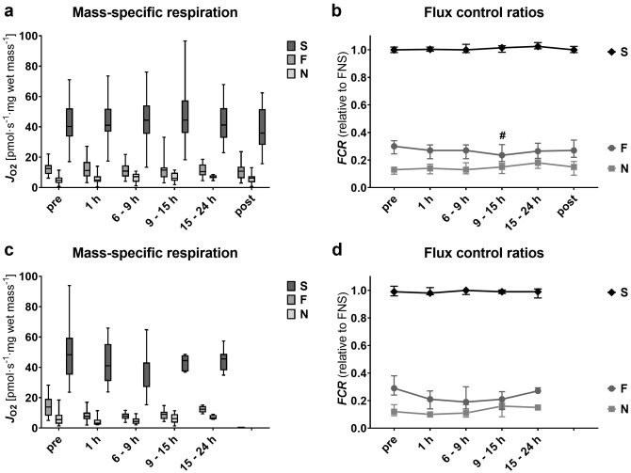
Figure 6: Comparison on liver condition

- HPE Examination:
Histopathological Examination (HPE) involves the microscopic examination of organ tissues or cells to assess their structure, morphology, and any pathological changes. When organs are procured from deceased donors for transplantation, they undergo a thorough evaluation to ensure their suitability for transplantation. HPE is one of the crucial steps in this evaluation process. It helps assess the quality and viability of the organ tissue, identifies any pre-existing damage or pathological conditions, and determines if the organ is suitable for transplantation. During Prolonged Normothermic Machine Perfusion, HPE may be performed on tissue samples obtained from the perfused organ at specific time points during the perfusion process. The examination allows the assessment of the organ's response to perfusion, the effects of reperfusion injury, and any changes in the tissue over time. The grading and interpretation of histopathological findings play a significant role in deciding whether the organ is suitable for transplantation or if it needs to be discarded.

- Cytokine Filter:
The potential use of cytokine filters during NMP could be to mitigate the inflammatory response in the perfused organ and reduce the risk of ischemia-reperfusion injury. By removing excessive cytokines from the perfusate, the filters may help protect the organ from inflammatory damage and improve its viability for transplantation. Cytokine filters work based on the principle of adsorption, where certain substances are selectively removed from the blood as it passes through the filter. The filter contains specific materials that can bind and remove cytokines and other inflammatory mediators from the blood. By doing so, the cytokine filter helps modulate the immune response and reduces the levels of harmful cytokines in the circulation.
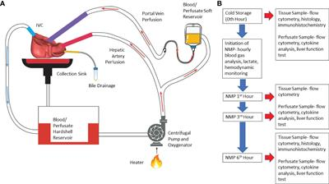
Figure 7: Process of Cytokine Filter

